Auto Scaling Group- ASG

- Create one VPC in N. Virginia region.
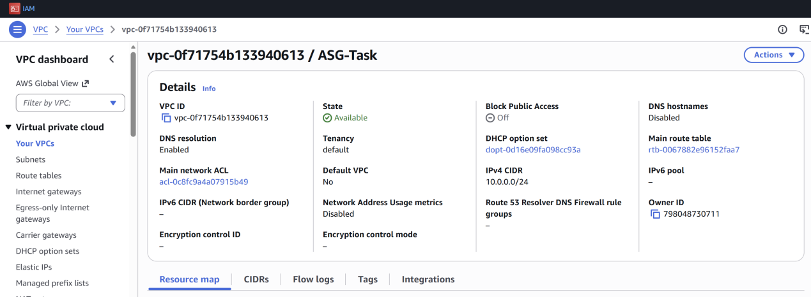

- Create two subnets: one public subnet and one private subnet.
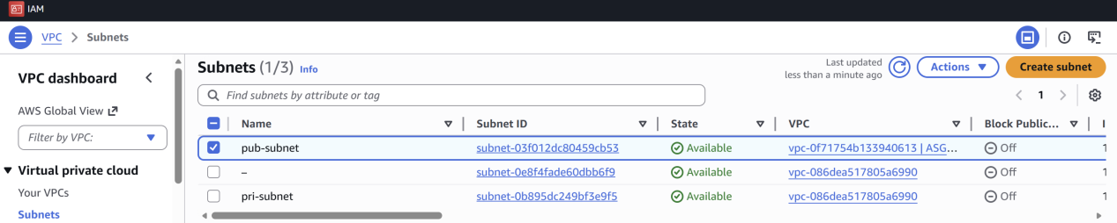

- Attach an IGW to the VPC.
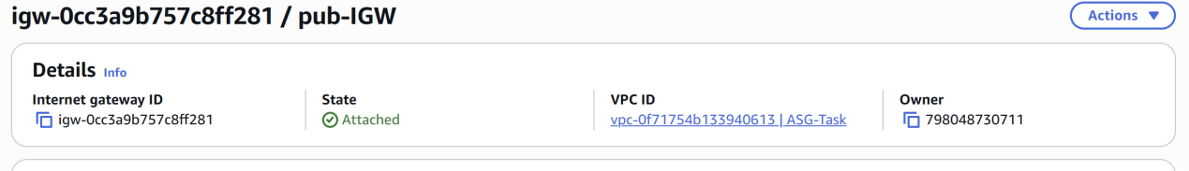

- Create one public route table (RT) and one private route table.
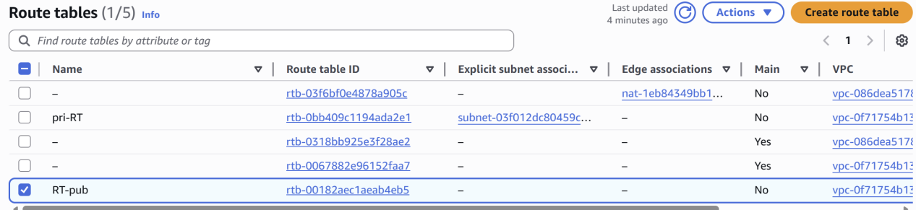

- Deploy a NAT gateway in the public subnet and attach the NAT gateway to the private subnet.
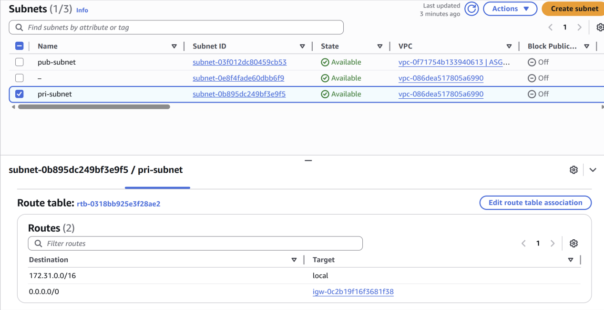

- Create two instances, one in the public subnet and one in the private subnet.
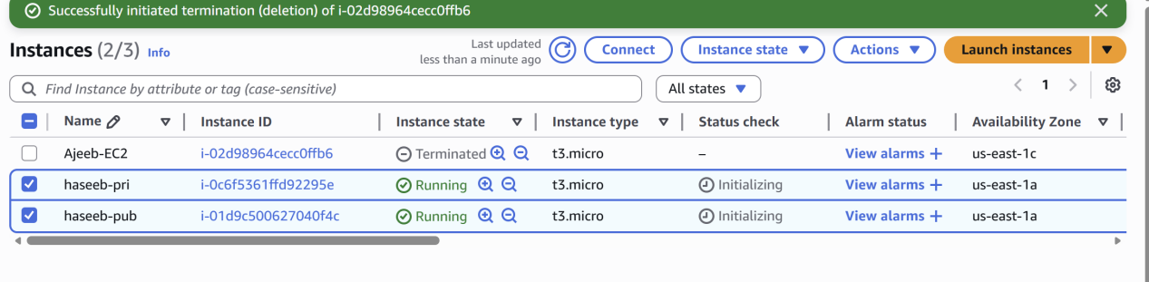

- Deploy Apache server on both EC2 instances with a sample index.html file.

Public Instance
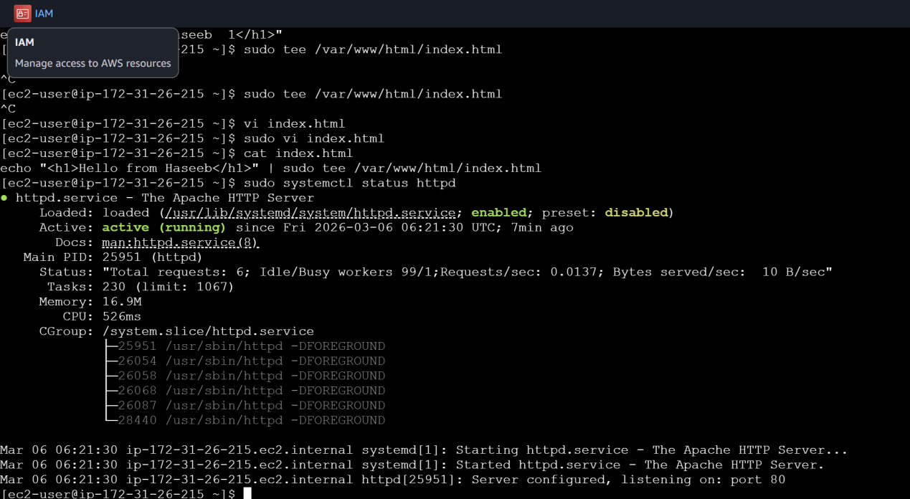


- Create one application load balancer and attach it to both EC2 instances.

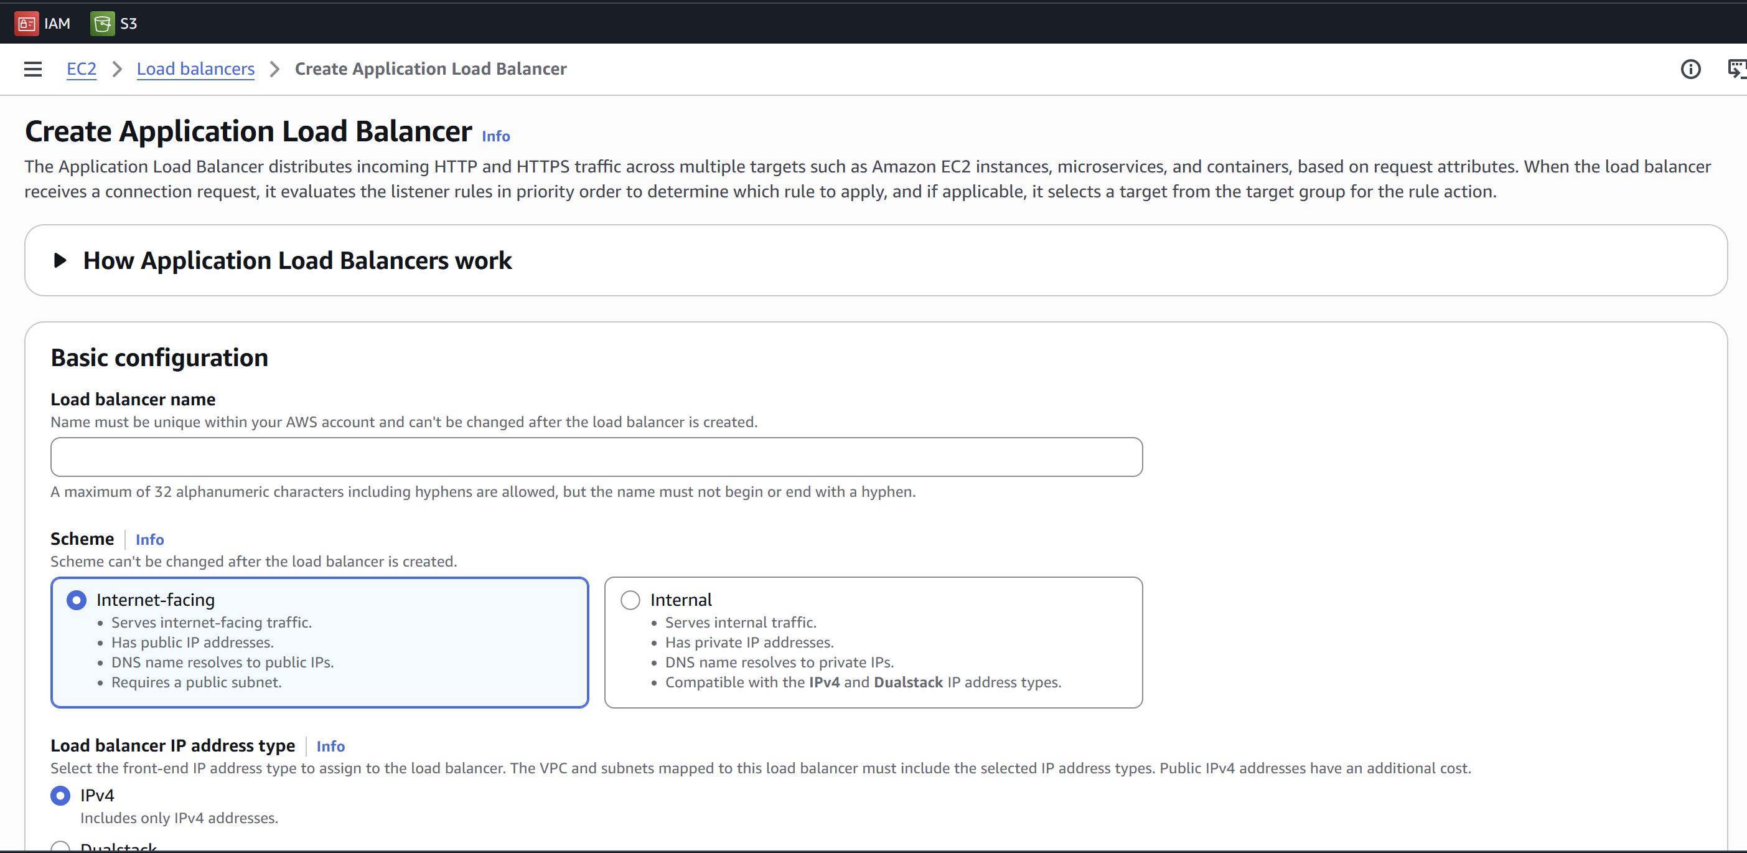
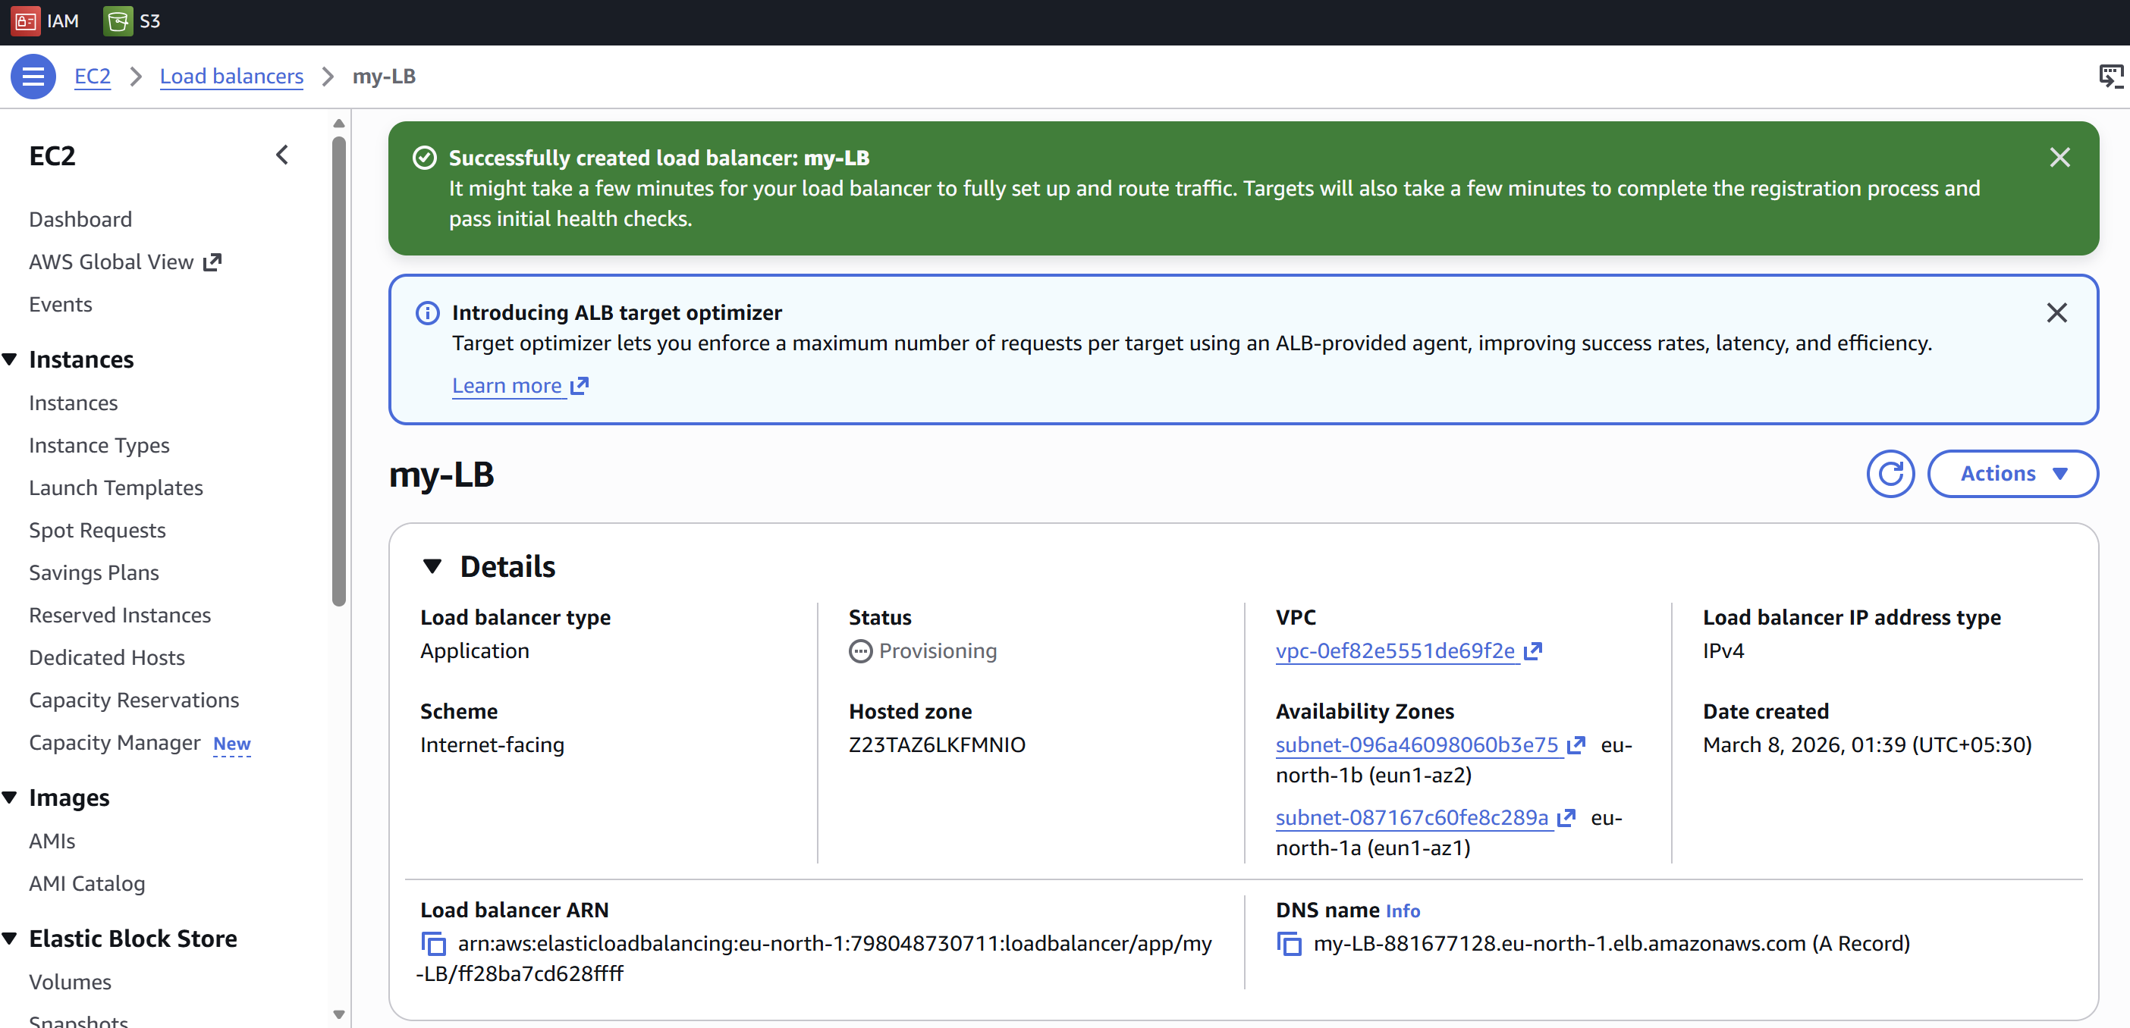

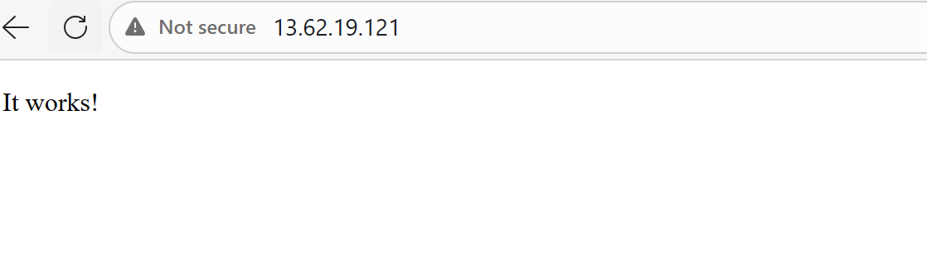

- Store application load balancer logs in S3.
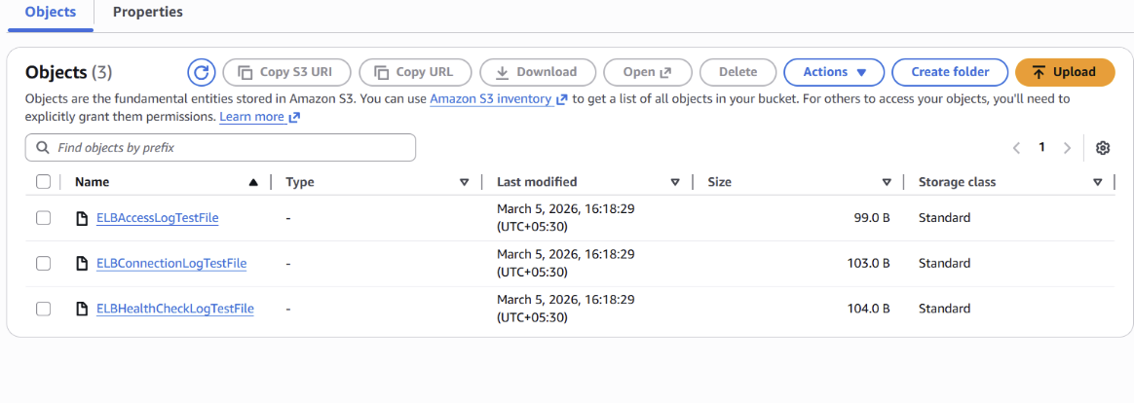
- Store the VPC flow logs in a CloudWatch log group
Select the particular VPC and click on flowlogs and create one flowlog
Go to cloudwatch > Log management > Log group, select the existing one or create it and you should see this…
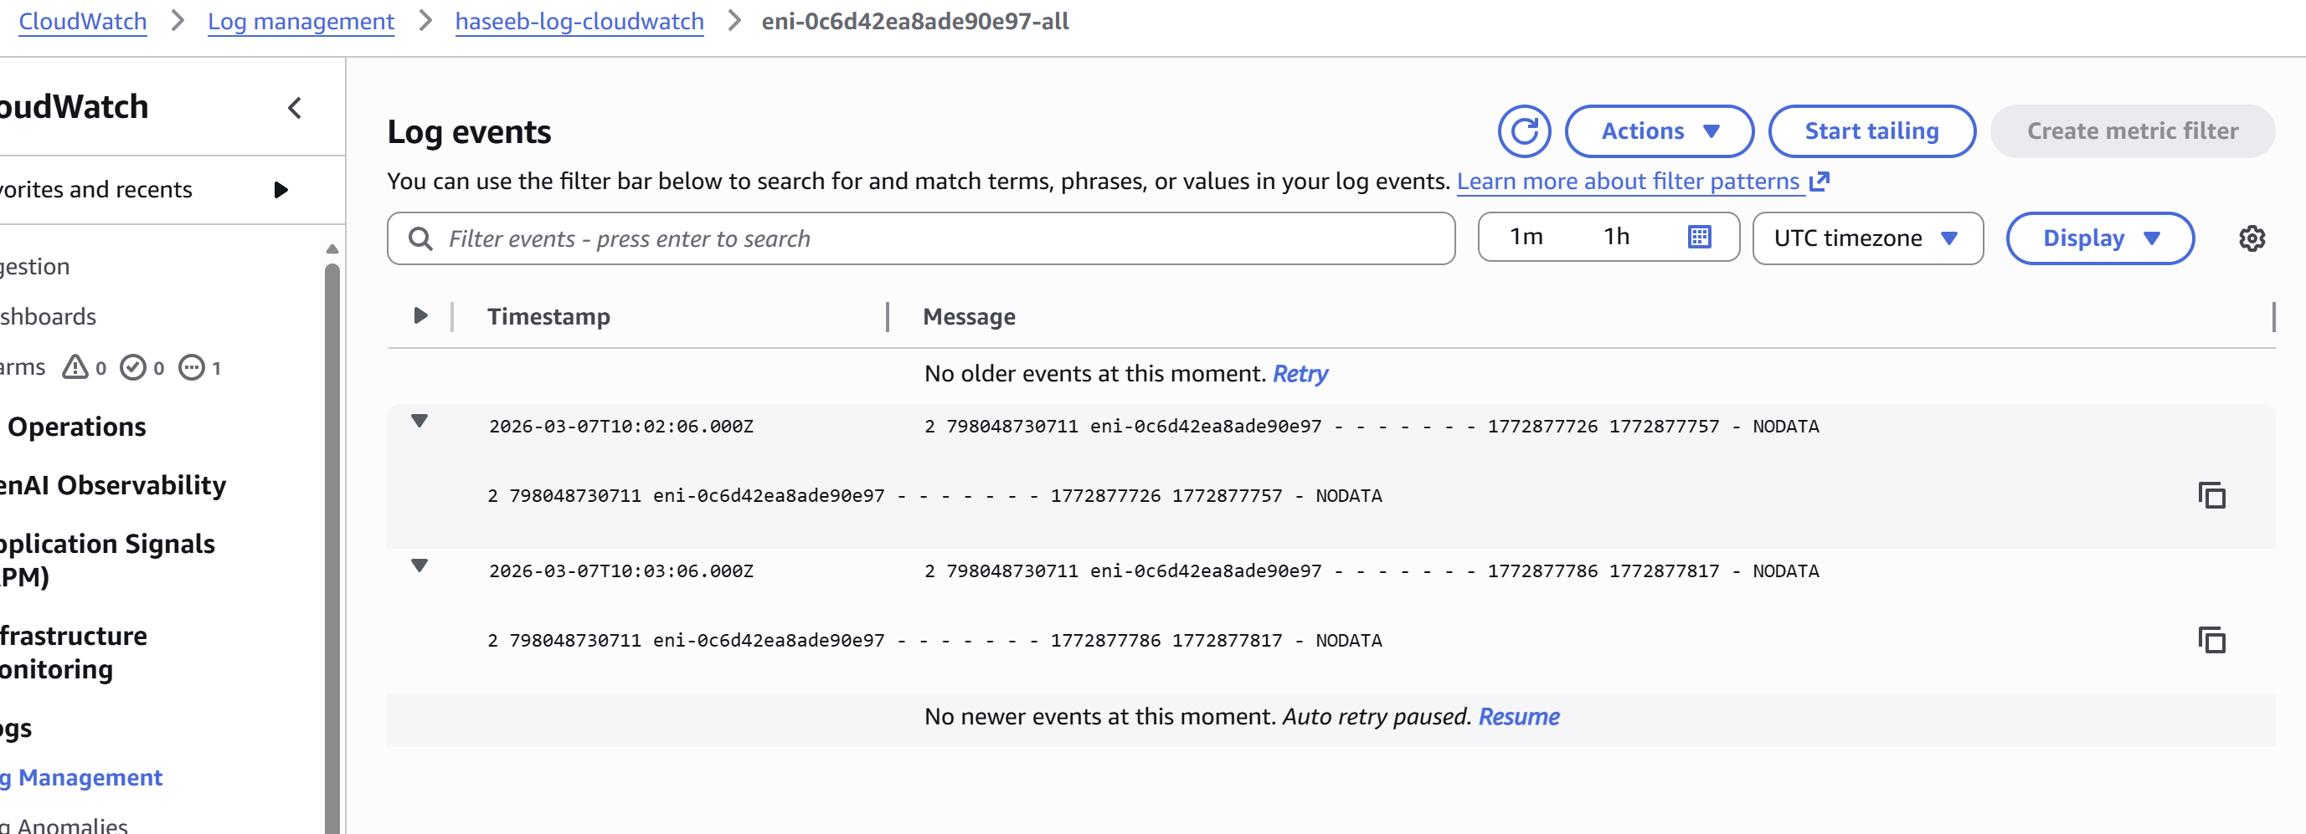

- Create monitoring dashboards to monitor CPU utilization and to
monitor the Apache service.
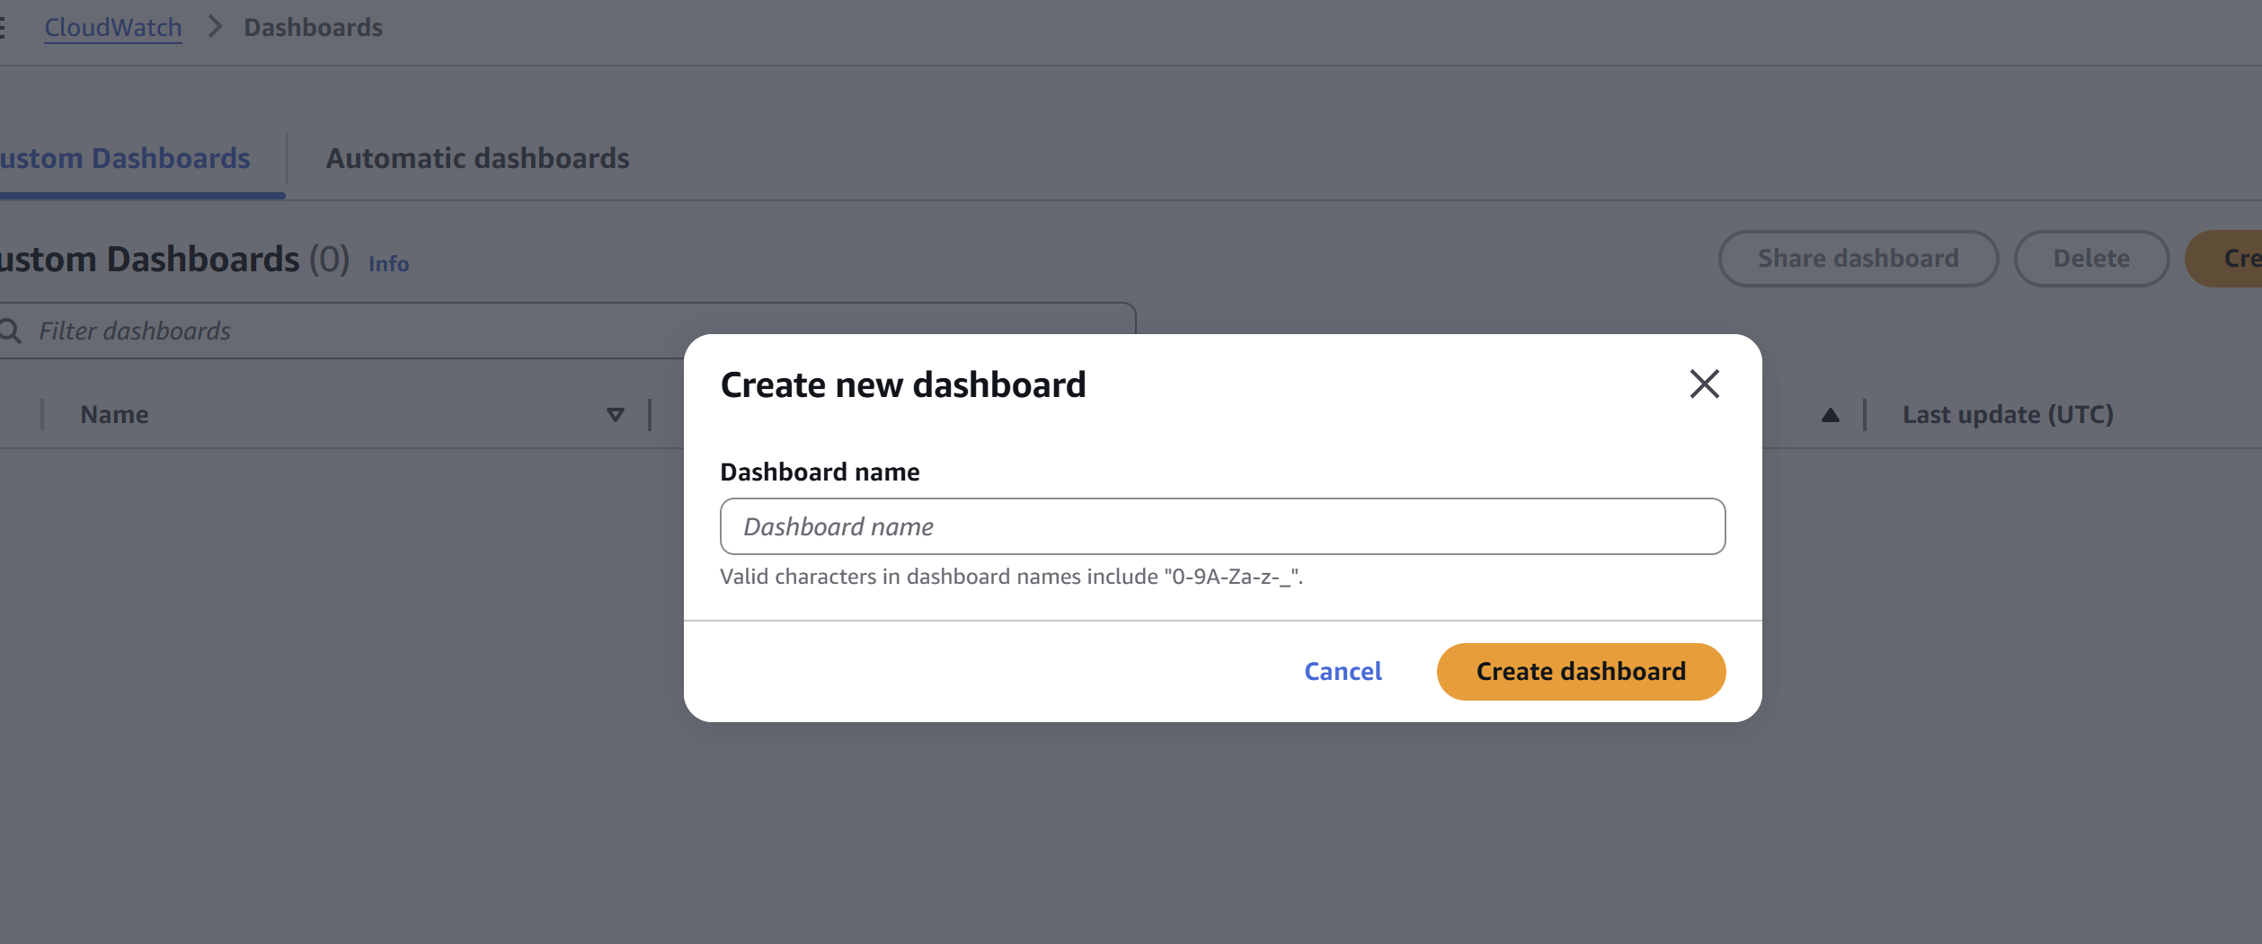
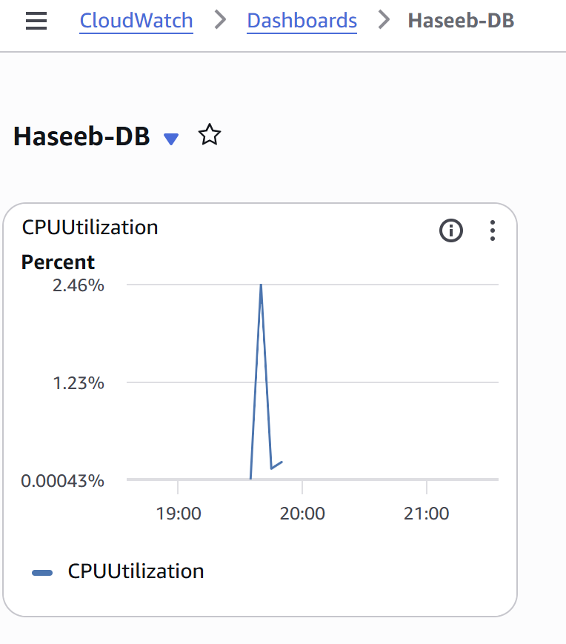
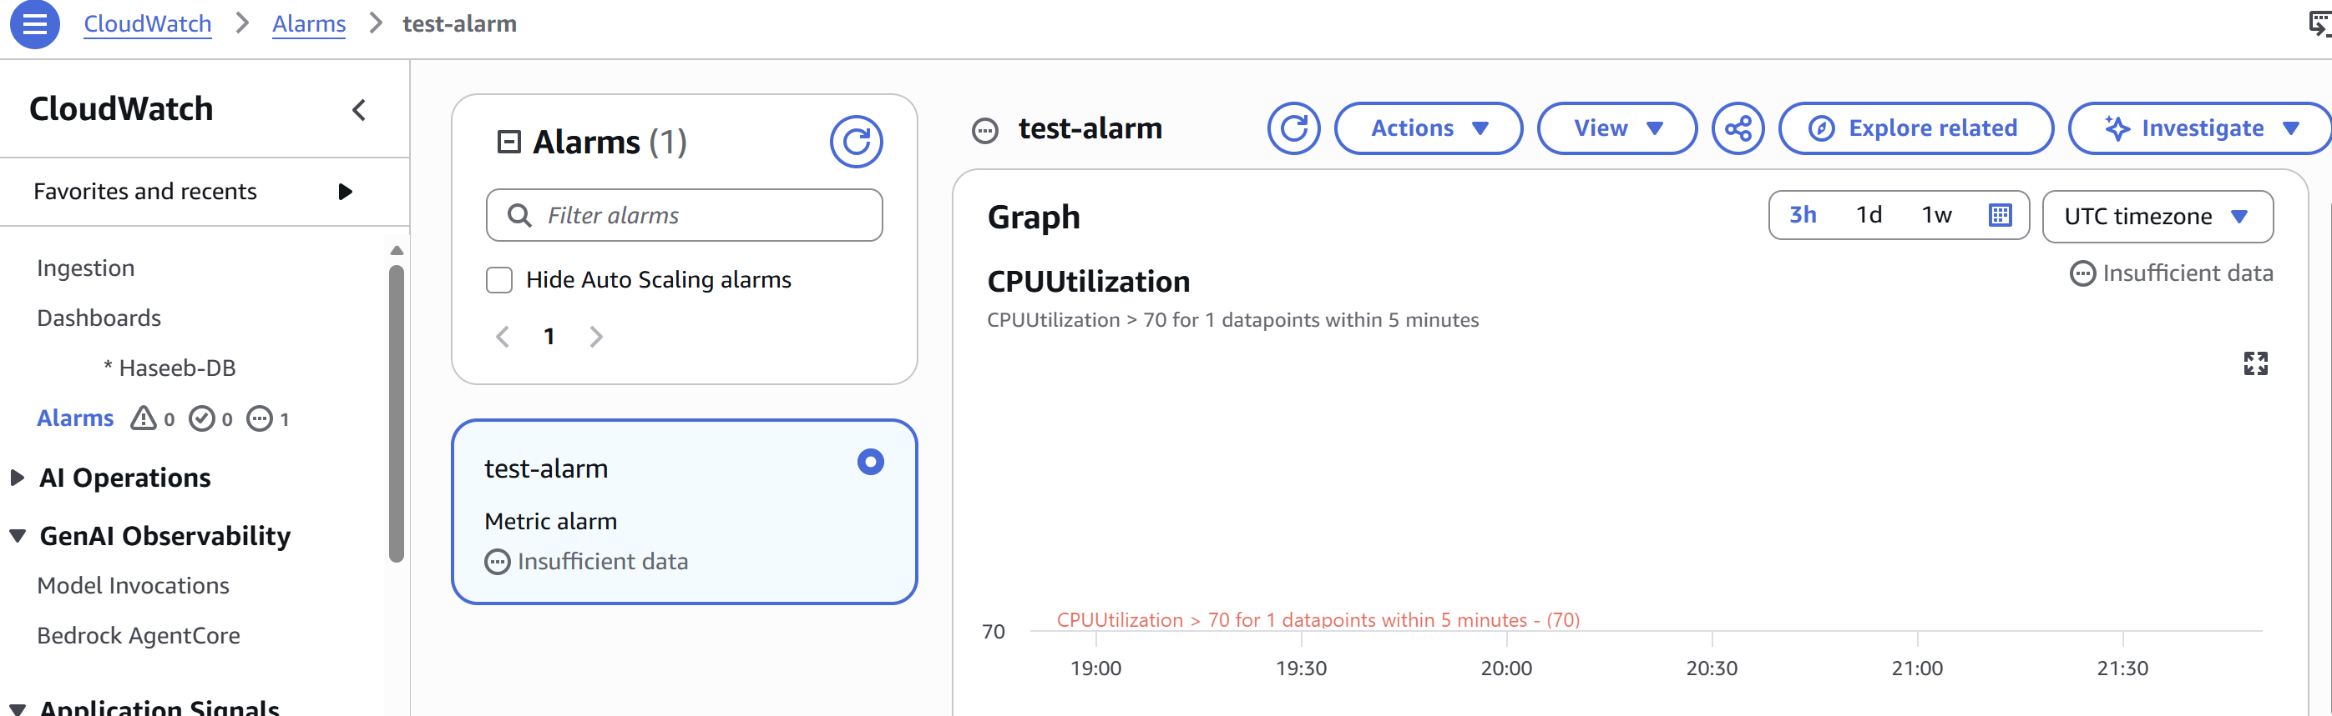

- If CPU utilization is more than 70%, then it should trigger auto scaling
and launch new instance
Auto Scaling Based on CPU
Go to Auto Scaling Create Auto Scaling Group→
First create Launch Template
Create Scaling policy
70%
Now:
If CPU > 70%
New EC2 instance will launch automatically
